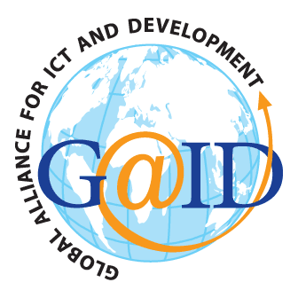 |  | 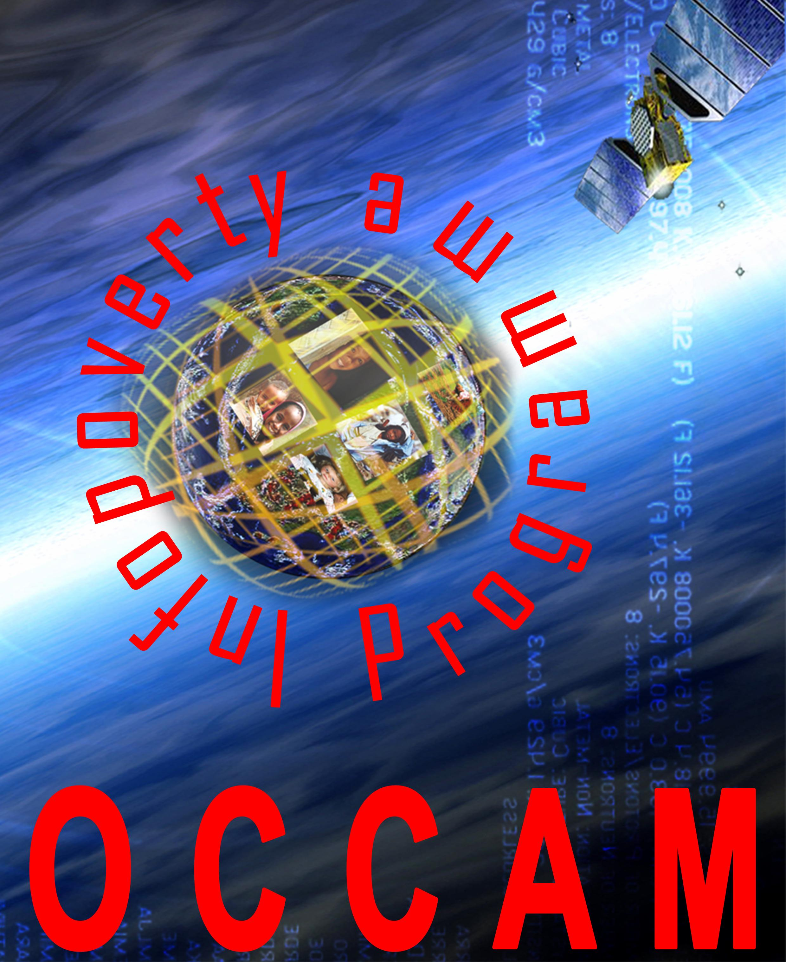
GLOBAL ALLIANCE FOR ICT AND DEVELOPMENT | UNITED NATIONS  COMMISSION ON SCIENCE AND TECHNOLOGY FOR DEVELOPMENT | OBSERVATORY FOR CULTURAL AND AUDIOVISUAL COMMUNICATION

Panel discussion on

“Information Society: New Perspectives for Post-WSIS Scenarios?”
5 July 2007, Palais des Nations, Geneva, Switzerland
Conference Room XXVI
3.00 p.m. to 6.00 p.m.

DRAFT AGENDA

3:00 – 6:00 | Welcome by Mr. Sarbuland Khan, Executive Coordinator of the Global Alliance for ICT and Development  Opening Remarks  Mr. Hamadoun Touré, Secretary-General of ITU  Moderator  Mr. Philippe Mottaz, World Radio Geneva  Lead discussant  Mr. Alain Clerc, Executive Secretary, Digital Solidarity Fund  Panelists  Mr. Talal Abu-Ghazaleh, Chairman and CEO, Talal Abu-Ghazaleh Organization (TAGO)  Mr. John Gage, Chief Researcher and Vice-President of the Science Office, Sun Microsystems  Ambassador Janis Karklins, Vice-Chair, United Nations Commission on Science and Technology for Development  Mr. Carlo Ottaviani, President, ST Microelectronics Foundation  Mr. Supachai Panitchpakdi, Secretary-General of UNCTAD  Mr. Gerolf Weigel, Head of ICT4D Division, Swiss Agency for Development and Cooperation

