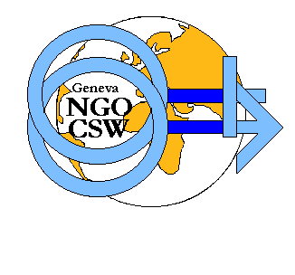

COMMITTEE ON THE STATUS OF WOMEN (CSW) of
CONFERENCE OF NON-GOVERNMENTAL ORGANISATIONS IN CONSULTATIVE STATUS WITH THE UNITED NATIONS (CONGO)
in collaboration with

FEMMES AFRICA SOLIDARITE (FAS)

AND
ASSOCIATION TUNISIENNE DES MERES (ATM)

INVITE

TO AN INTERACTIVE ROUNDTABLE

on, 8 December 2003, at Palexpo
from 14:00-18:00

IN ROOM A

Human Rights of Women in the Information Society and the Digital Divide
BEST PRACTICES ICT USERS

EXPERTS INTERGENERATIONAL

INTERACTIVE DIALOGUE REPRESENTATIVES FROM
THE NORTH & SOUTH

Translation English/French/Spanish will be available.

For further information on the Panel, feel free to contact Leana Islam at FAS: 022 328 80 50.

