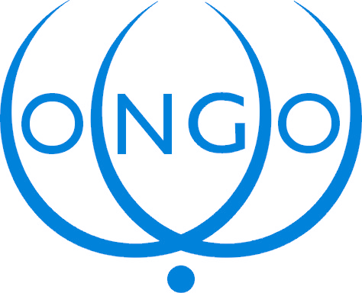

INFORMATION – TECHNOLOGY – HUMAN RIGHTS

The Conference of NGOs in Consultative Relationship with the United Nations (CONGO)
Invites you to a Briefing on

THE WORLD SUMMIT ON THE INFORMATION SOCIETY/TUNIS PHASE
Considerations for the Human Rights Community

Wednesday, 13 April, 11:00 – 13:00
Room XXVII

Speakers:

Janis Karklins President, PrepCom
Charles Geiger Executive Director, WSIS Secretariat
Markus Kummer Executive Coordinator, Working Group
On Internet Governance
William Drake President, Computer Professionals for Social Responsibility

Moderator:

Renate Bloem President CONGO

