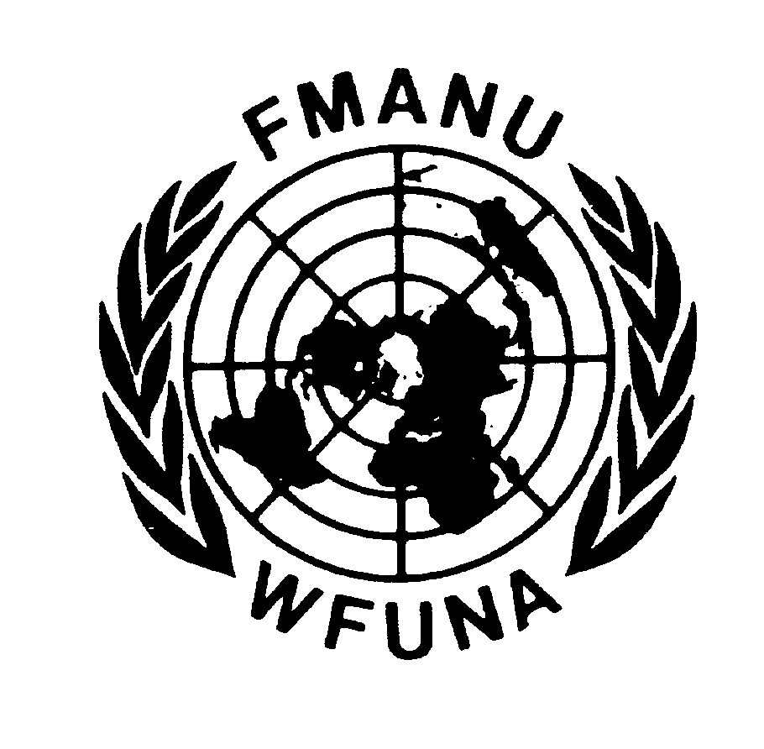


WORLD FEDERATION OF UNITED NATIONS ASSOCIATIONS

FEDERATION MONDIALE DES ASSOCIATIONS POUR LES NATIONS UNIES

A peoples’ movement for the United Nations

Draft
PROGRAMME

Seminar on the United Nations Human Rights Council

In cooperation with the Office of the United Nations High Commissioner for Human Rights

Geneva, 26 – 28 July 2006

Palais des Nations, Room XVI

Wednesday 26 July

8:00 Registration

10:00 Welcome Statements
Statement from the Office of the Director-General of the United Nations in Geneva
Statement from the Office of the High Commissioner for Human Rights
Statement from the Vice-President of the Human Rights Council

11:30 Briefing and Introduction to the Seminar
Mrs. Bruna Molina Faidutti, Deputy Secretary-General of WFUNA

Lunch

15:00 The Human Rights Council: Its Creation and an Analysis of the First Session
Mr. Eric Tistounet, Secretary of the Human Rights Council

16:30 The Mandate of the Office of the High Commissioner and the UN System for the
Protection of Human Rights
Mrs. Francesca Marotta, Coordinator of the Methodology Unit and Field Presences, OHCHR

Thursday 27 July

10:00 Applicable Rules of Procedure for the Human Rights Council
Mr. Guennadi Lebakine, Deputy Secretary of the Human Rights Council

11:30 Special Procedures and their Relationship with the Treaty Bodies
Sir Nigel Rodley, Member of the Human Rights Committee

Lunch

14:00 The Structure and Jurisdiction of the Human Rights Council
Mr. Walter Kälin, Representative of the Secretary-General on the Human
Rights of Internally Displaced Persons

15:00 Towards a Unified Human Rights Treaty Body Corpus
Mr. Markus Schmidt, Senior Human Rights Officer, OHCHR

16:00 The Question of the Sub-Commission and the Complaints Procedure
Ms. Maria Andrea Echazu, Human Rights Officer, OHCHR

Friday 28 July

10:00 The Universal Periodic Review Mechanism
Mr. Andrew Clapham, International Law Professor at the Graduate Institute of International Studies, Geneva

11:00 The Contribution of Non-Governmental Organisations to the Human Rights Council (TBC)
Mr. Wolfgang-Amadeus Bruelhart, Head of the Human Rights Policy Section at the Swiss Federal Department of Foreign Affairs, Political Division IV, Human Security
Mrs. Mariette Grange, Geneva Advocacy Director at Human Rights Watch
Mrs. Laura Dolci-Kanaan, OHCHR - NGO Liaison Officer
Mr. Peter N. Prove, Office for International Affairs and Human Rights, the Lutheran World Federation
Dr. Theodor Rathgeber, German Forum Human Rights

Lunch

15:00 Conclusion of the Seminar and Distribution of Certificates



Geneva International Academic Network
Graduate Institute of International Studies

