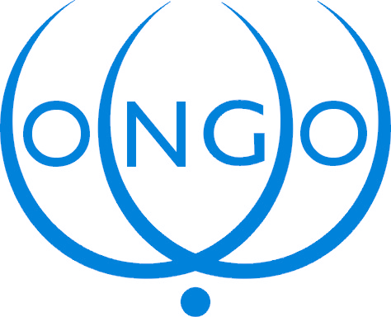

Conference of NGOs in Consultative Relationship
with the United Nations (CONGO)
ECOSOC substantive session – Items 6 and 13 (b)
19 July 2007

Mr. President,
Distinguished Delegates,

As part of the trend for its strengthening, ECOSOC has promoted an integrated and coordinated approach to the various conference follow up processes. We thank the UN Secretary General for his report. I would like to present a few comments to his report E/2007/76 on enhancing the efficiency of the conference follow up process through the lens of strengthening the involvement of civil society, and on the follow up to the World Summit on the Information Society.

Enhancing the efficiency of the Conference follow up process through the lens of strengthening the involvement of civil society
We are pleased to see once more the UN Secretary General’s recognition of the significant increase of civil society participation in the work of the United Nations and in the implementation of the UN development goals. The Secretary General noted that bringing the different follow up processes together and establishing new ECOSOC functions would promote a greater interaction among all constituencies. We could not more agree with that. The ECOSOC High Level Segment demonstrated that these new working functions would strengthen its capacity to address global issues. At the same time, the ECOSOC would also benefit from a higher degree of involvement and contribution from NGO partners in reviewing progress in implementation in a cross-sectoral manner. The Conference of NGOs is ready to engage in a dialogue on how to further attract civil society contributions to ECOSOC activities in the perspective of the comprehensive ECOSOC reform resolution, which is expected to elaborate further on resolution 61/16.

First, informal consultations with civil society actors should be held during the process of drafting of the ECOSOC Ministerial Declaration. More transparency in the drafting process would indeed facilitate inputs from NGOs at some stages of the process, but would also increase the visibility for the Council’s work and further encourage NGO actors to engage in disseminating and implementing the provisions included in the ministerial declaration.

Secondly, on the Annual Ministerial-level Review, we call countries under voluntary review during future sessions of the Council to organise an inclusive national consultation process involving civil society actors. In addition, the Council should adopt a flexible way of involving NGOs in the AMR proceedings, to guarantee that NGO inputs be fully included in the AMR programme. This would help create a space for genuine and constructive dialogue between all stakeholders involved in the implementation of international development targets.

Follow up to the outcomes of the World Summit on the Information Society
I would now like to comment on the paragraphs devoted to the WSIS implementation and follow up (para. 12 to 14), and in particular on the reference that contributions from non-governmental stakeholders to CSTD were “channelled through the multi-stakeholder Global Alliance for ICTs and Development”.

The Conference of NGOs is of the opinion that this assertion does not accurately reflect paragraph 105 of the Tunis Agenda for the Information Society and the provisions of Resolution 2006/46 adopted last year by ECOSOC. In line with the practice of ECOSOC subsidiary bodies, with the arrangements observed during CSTD-10 and with the provisions of ECOSOC resolutions 1996/31 and 2006/46, non-governmental organisations observing the CSTD are able to directly contribute to its work. We understand that GAID, as an initiative created by the UN Secretary General in March 2006, is a catalyser for multi-stakeholder and action oriented partnerships and a multi-stakeholder platform for cross-sectoral policy dialogue, with the view to harness the use of ICTs towards achieving the UN development agenda, including the MDGs.

We once more support the Global Alliance as a very significant tool for the implementation of the development goals, and it should continue to play an important role in the follow up and implementation of WSIS. We also encourage all actors concerned to also engage in its work. In that sense, there is a great interest that GAID feeds into the work of the CSTD and of ECOSOC and provide its input as the result of its standing multi-stakeholder processes. We were in particular fully pleased by the one-day CSTD-GAID joint event organised during the May 2007 session as a very positive innovation that must be continued. However, the Global Alliance should not be considered as the only multi-stakeholder process of the CSTD, but only as one of them. We therefore object that the Global Alliance could be used to channel the participation of NGOs in the CSTD process, since it would represent a serious step backwards in the multi-stakeholder approach to be taken into account through the WSIS follow-up performed by the CSTD.

I’ll be happy to further develop on the successful 10th CSTD session of May 2007 and on the very significant work delivered by GAID during the consideration of the CSTD report on 25 July.

